What does park visitation popularity and trends look like in recent years and what are some other trends or correlations related to the visitation trends?

Using the NPS data, we wanted to explore what national parks visitation in recent years. Our hypothesis was that we would see a large increase, and our hypothesis was correct. Looking at trends for recreational visitor, tent camper, and backcountry camper numbers, there is a huge rise starting in 2013.

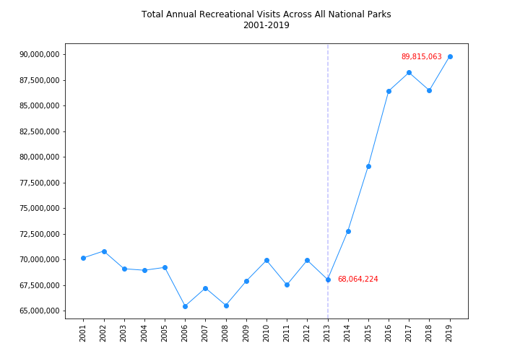

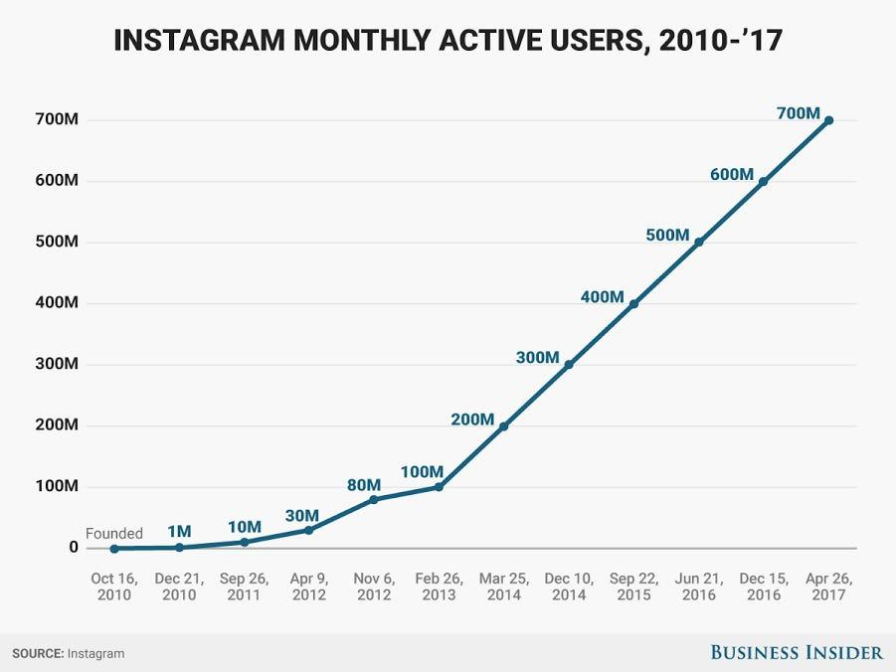

Part of our hypothesis for the increase in numbers is that social media has impacted the rise in park popularity. Obtaining historical Instagram data through the API proved to be impossible with the resources given. We did however find that similar to the parks visitor graph, there seems to be an inflection at 2013 and a large increase in Instagram users which very much may have impacted the rise in national parks popularity.

Utilizing twitter API, we also wanted to see if there were trends in social media engagement and park popularity.

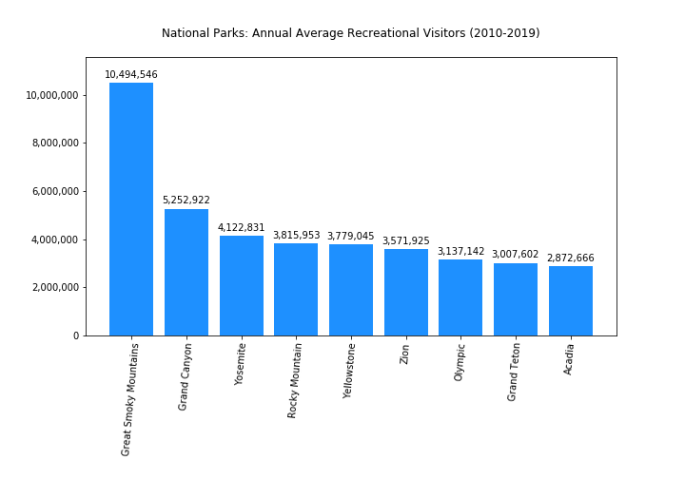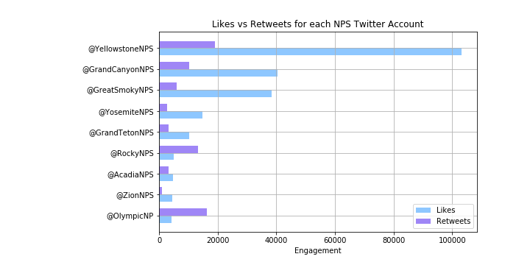

The graph (Likes vs Retweets) provides a general view of popularity by volume of likes and retweets on each park's last 200 tweets. These high-level volumetrics seem to correlate slightly positively with the park visitation.

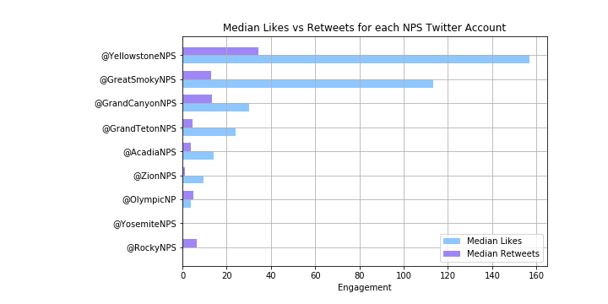

The second graph (Median Likes vs Retweets) shows a better representation of the middle. We chose to use median as opposed to mean because the data was heavily skewed and this provided a better measure of the middle. It was a skewed distribution since some tweets had thousands of likes and retweets and others (like those replying to followers, had zero or one).

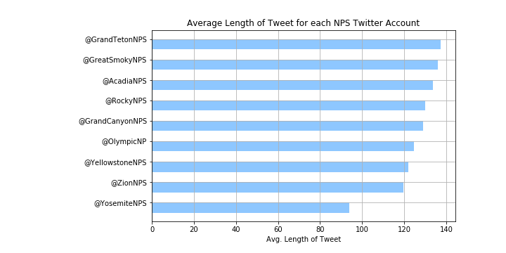

The third graph looks at the average length of each tweet. Unfortunately there isn't much of a relationship, negatively or positively, between park visitation and average length of a tweet.

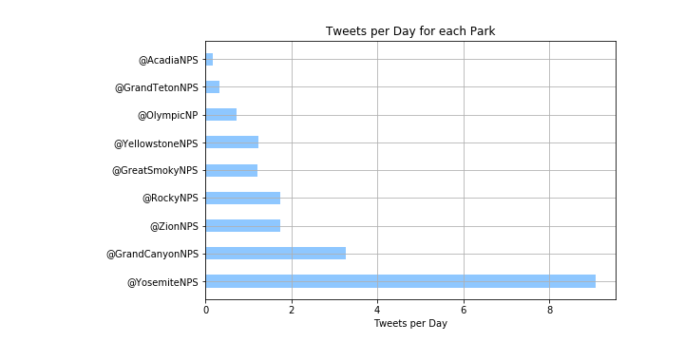

The final graph is a visualization of tweets per day. This takes into account that we were only able to grab the last 200 tweets for each park's Twitter account, and because of this, it's a better overall measure for engagement. And there's a strong correlation between the most frequent tweeters and the most visited parks. Causality cannot be determined, but they are positively correlated, which supports our hypothesis that twitter engagement mirrors park visitation.

Lastly, we wanted to observe the potential impact of rising national parks visitors with outdoor recreational business. As a test, we chose to look at REI’s membership and sales data as REI is the most widespread and popular outdoor recreation store in the US. While the trends do not show a spike in membership in 2013 as we saw in the national park visitor increase, we still do see an impressive steady rise which may be attributed to the increase in national parks popularity. The sales data also shows a fairly linear increase, but there does seem to be a slight increase in slope after 2013 of about $50 million. While there isn’t direct evidence, the continued large and steady increase in sales and membership may be attributed to the rising popularity in national parks.

